**Unit testing**

The tests:

For this stage we will test the ‘authorise’, ‘create personal details’, ‘read personal details’ and ‘amend personal details’ functionalities of the program. For this, we will need to test:

* Whether or not the user is authorised to perform different actions depending on their position in the company
* Whether or not details can be read
* Whether or not documents can be created
* Whether or not details can be amended
* Checking amended details are updated in the database

All of the above tests will require a target username, the current user and the action name.

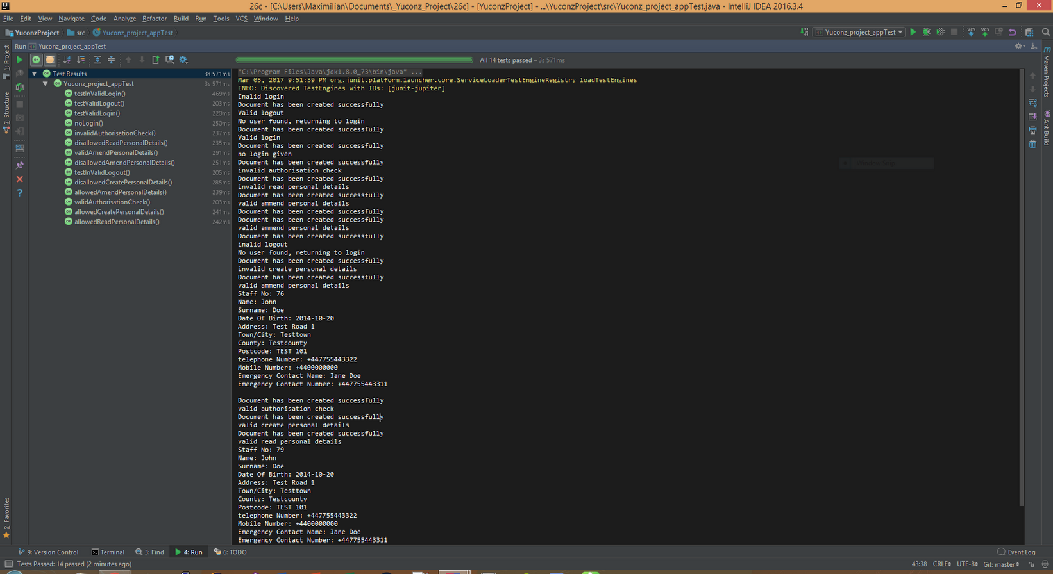

The final iteration of the application for stage 4 passes all the JUnit tests from stage 3 and the present section and as such is ready for submission.